Magnetic field, Magnetic field intensity, Magnetic flux and flux density
The magnetic field is defined as the region around the magnet where its poles and the electrical charges experience the force of attraction or repulsion. The presence of the field is determined through the needle. In actual practice, the magnetic field has no real existence, and they are purely imaginary. The magnetic field is created because of the magnetic line of force which possesses the following properties.
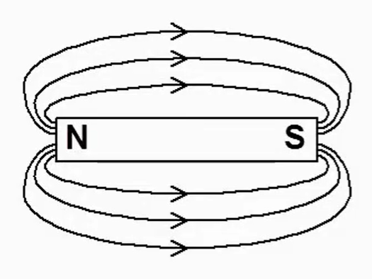

- The magnetic line of force forms the closed loop.
- The direction of magnetic line force is from north to south.
- The magnetic lines never intersect each other.
- The magnetic lines repel each other when they are parallel and in the same direction.
- They are not affected by the non-magnetic materials.

Definition of Magnetic Flux
The magnetic flux is defined as the total number of magnetic lines of force produces by the magnet. It is measured in Weber. The one Weber is equal to the 10⁸ line of forces.

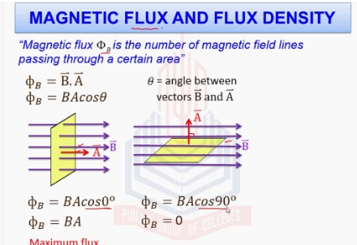
Magnetic flux density (B) is a measure of the concentration or strength of a magnetic field at a specific point. It is defined as the number of magnetic field lines passing through a unit area perpendicular to the direction of the field. In more practical terms, it is the force exerted per unit current per unit length on a conductor placed perpendicular to the magnetic field.

Magnetic force on a moving charge
Magnitude of the Force The magnitude of the magnetic force,F on a particle with charge q moving at a velocity v in a magnetic field B is calculated using the formula: F=qvBsinθ. In this equation, θ represents the angle between the velocity vector and the magnetic field lines.
Maximum Force: The force is strongest when the charge moves perpendicularly to the field lines θ = 90⁰.
Zero Force: The force is zero if the charge moves parallel or anti-parallel to the field lines (θ = 0 or 180⁰.
Velocity Dependence: The force increases with higher velocity, greater charge, or stronger magnetic field strength. Direction of the Force The magnetic force is always perpendicular to both the velocity of the charge and the magnetic field. To determine this direction for a positive charge, physicists use Right Hand Rule
Lorentz force
The Lorentz force is the combined electric (qE) and magnetic (qvxB) force on a charged particle moving through electromagnetic fields, defined by F=qE+qvxB
It dictates that a current-carrying conductor in a magnetic field experiences a force perpendicular to both current and field.

